TOSHA KHANA ANALYSIS

Sr. | Name | Roll No | Section
1. | Muhammad Abdullah | 24F-3097 | BSSE-4A
2. | Muhammad Ehtasham | 24F-3098 | BSSE-4A
3. | Hammad Hafeez | 24F-0581 | BSCS-4F
4. | Faiq Ali | 24F-0533 | BSCS-4F
5. | Muhammad Abdullah | 24F-0613 | BSCS-4F

Problem Statement:
The Toshakhana case in Pakistan represents a significant governance and accountability issue involving the receipt, declaration, valuation, and retention of state gifts by public office holders. The Toshakhana literally meaning “treasure house”is a government-managed repository where gifts received by officials from foreign dignitaries, heads of state, and international delegations are deposited in accordance with established state protocols.
Over time, concerns have emerged regarding the transparency and compliance of this system. Allegations suggest that several high-ranking officials, including former presidents, prime ministers, and senior bureaucrats, retained valuable gifts such as luxury watches, jewelry, and vehicles either without proper declaration or by undervaluing them to acquire these items at significantly reduced prices. These practices raise critical questions about adherence to ethical standards, legal frameworks, and financial accountability within public office.
In 2018, the Supreme Court of Pakistan took suo motu notice of the matter and directed the National Accountability Bureau (NAB) to conduct a detailed investigation into Toshakhana records spanning multiple administrations. The investigation revealed discrepancies in reporting, inconsistencies in valuation mechanisms, and potential violations of tax and asset declaration laws. Specifically, findings indicated that gifts worth millions of dollars were either not declared or were retained without paying the requisite government-assessed value or applicable taxes.
This controversy has triggered intense political and public debate. Critics argue that such actions constitute misuse of public office, breach of fiduciary duty, and erosion of institutional integrity. On the other hand, some stakeholders defend the practice, citing long-standing diplomatic traditions where gift exchange is considered a norm, and argue that existing Toshakhana policies allow officials to retain gifts under predefined conditions.
Despite these defenses, the lack of standardized valuation procedures, limited public disclosure, and inconsistent enforcement mechanisms highlight systemic weaknesses in the Toshakhana framework. Furthermore, the issue has evolved into a politically sensitive matter, often used as a point of comparison between different political parties and leadership tenures, thereby complicating objective analysis.
Given this context, there is a need for a structured, data-driven examination of Toshakhana records to uncover patterns in gift distribution, retention behavior, and valuation discrepancies. Such an analysis can contribute to a more transparent understanding of the issue, support evidence-based policy reforms, and strengthen accountability mechanisms in public administration.

Objectives
1. Affiliation-wise Gift Distribution Analysis
Evaluate the distribution of gifts across different political affiliations to identify which group has received the highest number of gifts. This includes computing total counts, relative proportions, and temporal trends (if time data is available). The analysis should also account for potential reporting biases or missing data.

2. Item-Level Popularity and Frequency Analysis
Identify and rank the most frequently gifted item categories (e.g., watches, jewelry, vehicles, etc.). This involves categorizing items, calculating frequency distributions, and optionally analyzing value-based rankings (total assessed value per item category vs frequency).

3. Comparative Analysis: PML-N vs PTI in the Toshakhana Case
Conduct a comparative evaluation between Pakistan Muslim League (N) and Pakistan Tehreek-e-Insaf in the context of the Toshakhana records.
This includes:
- Total number of gifts received
- Total assessed value vs retained value
- Retention behavior (percentage of gifts retained vs deposited)
- Identification of high-value outliers
The goal is to objectively highlight differences in patterns between the two affiliations.

4. Probabilistic Modeling of Gift Retention Behavior
Estimate the probability of gift retention for each affiliation and item category.
This involves:
- Defining retention as a binary variable (retained vs not retained)
- Computing conditional probabilities:
  - P(Retention | Affiliation)
  - P(Retention | Item Type)
- Optionally applying probabilistic models (e.g., logistic regression) to understand which factors most influence retention decisions.

5. Regression Analysis: Assessed Value vs Retention Value
Develop a regression model to analyze the relationship between assessed value (independent variable) and retention value (dependent variable).
Key components include:
- Model selection (linear regression as baseline, with possible extensions)
- Evaluating correlation strength and statistical significance
- Residual analysis to detect anomalies or inconsistencies
- Identifying whether retention value scales proportionally with assessed value or shows systematic deviation

Data Description:
Data Link: https://www.kaggle.com/datasets/zusmani/pakistan-toshakhana-files/data
- Detail of Gifts: Details of the gifts received, such as the type of gift, its specifications, or any unique characteristics.
- Item Category: Categorizes the gifts based on their type or nature, which could include categories like vehicles, jewelry, artwork, electronics, etc.
- Name of Recipient: Lists the names of the individuals who received the gifts, which may include government officials, dignitaries, or public figures.
- Affiliation: The affiliation or position of the recipient, such as their role in the government, diplomatic status, or any relevant organizational affiliation.
- Date: The date when the gift was received or when it was officially documented in the Toshakhana records.
- Assessed Value: The estimated value or worth of the gift, which could be based on market value, appraisal, or other valuation methods.
- Retention Cost: Costs associated with storing, maintaining, or safeguarding the gift within the Toshakhana facility.
- Retained: It indicates whether the gift was retained or kept within the Toshakhana inventory, or if it was disposed of, returned, or transferred elsewhere.
- Remarks: Additional notes, comments, or explanations related to the gifts, recipients, or any other relevant information that may not fit into the other columns.

Results:
Home Page containing a navigation bar for accessing other pages
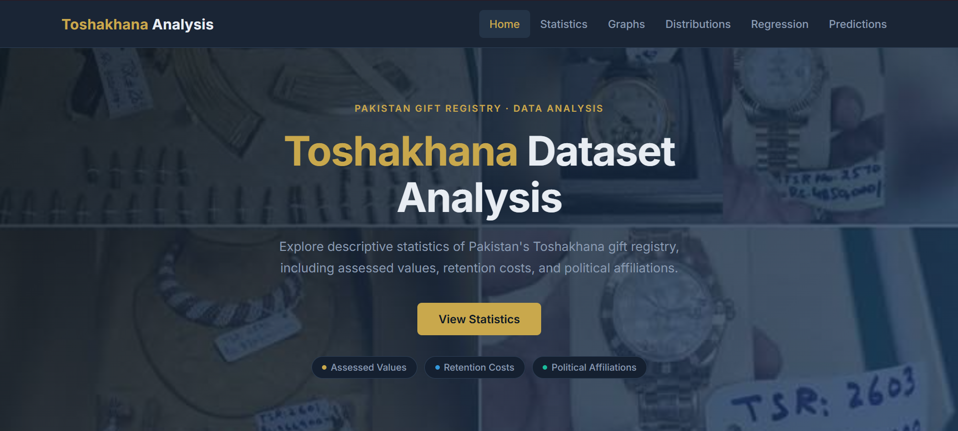
Statistics containing basic description of data containing mean, median, mode etc
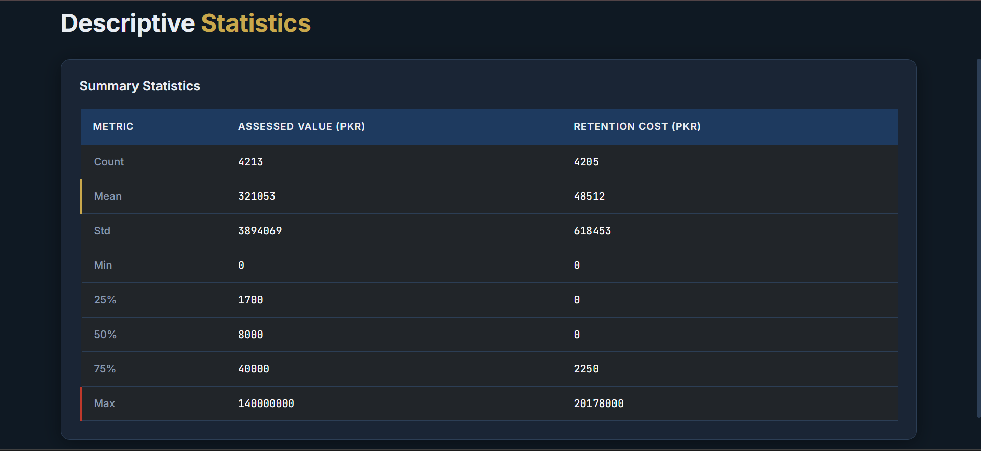

Graphs containing every possible graphical representation of the dataset.
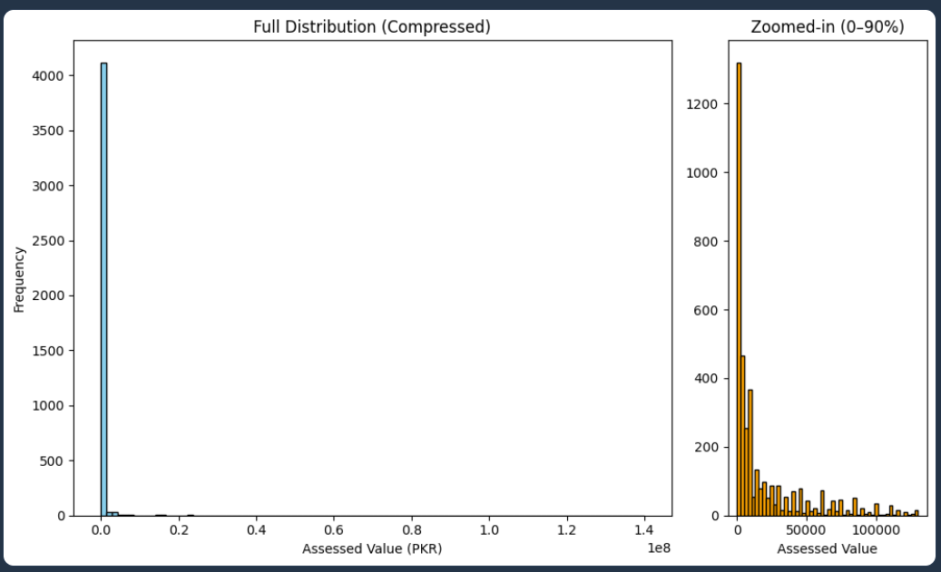

Description:
This dual-panel histogram visualises how assessed gift values are distributed across the entire Toshakhana dataset. The left panel shows the full compressed distribution — the extreme right skew immediately reveals that a small number of very high-value gifts dominate the range, pulling the mean far above the median. The right panel zooms into the 0–90th percentile range, stripping out those outliers to expose the shape of the typical gift: most items cluster in the lower value bands, with frequency dropping off sharply as value increases.
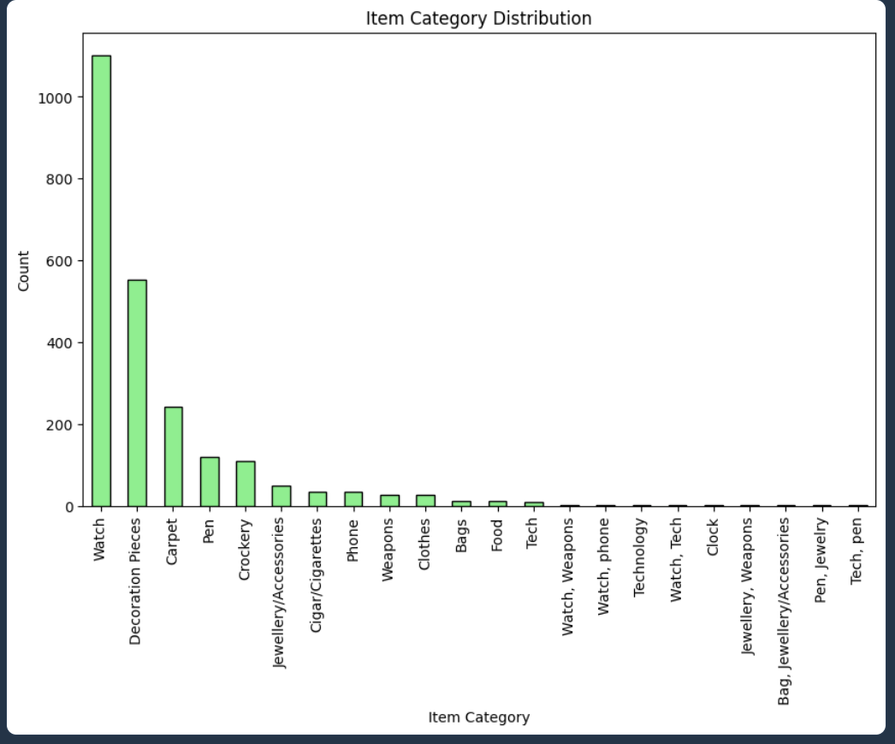

Description:
This bar chart breaks down the Toshakhana registry by item category, showing how many gifts fall into each type. It answers the question: what kinds of gifts are most commonly received by Pakistani officials? Categories like watches, shawls, and decorative items tend to dominate, reflecting the nature of diplomatic gifting culture in the region. The chart makes it easy to spot which categories are rare versus routine.
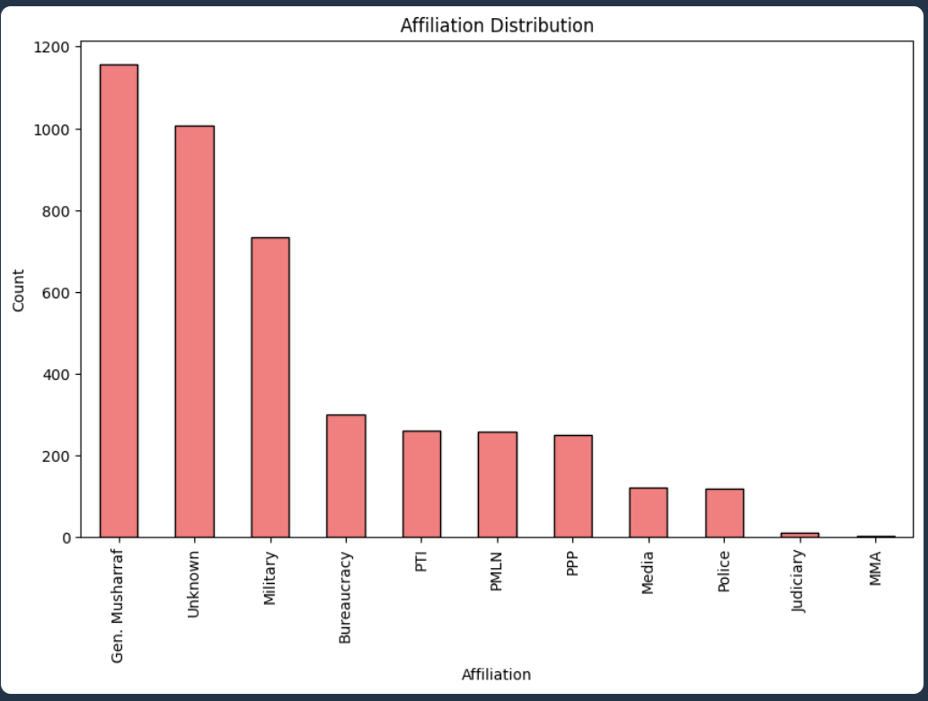

Description:
This bar chart shows how many Toshakhana gifts are associated with each affiliation — political parties, military figures, bureaucrats, and other groups. It reveals which affiliations have the highest representation in the registry, which is closely tied to which groups held power during the periods covered by the dataset. PTI and PMLN affiliations tend to dominate given the time span of the data.
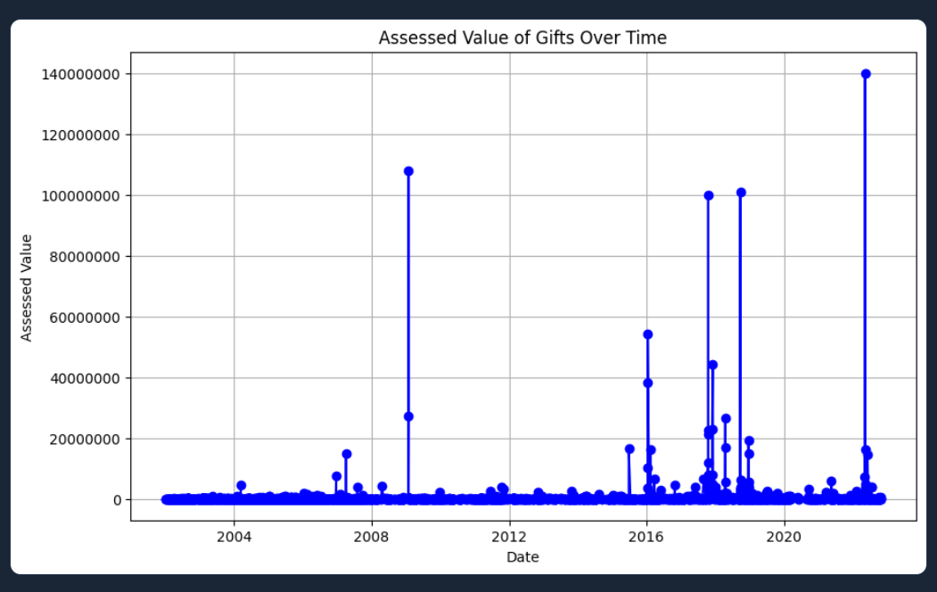

Description:
This time-series line chart plots each gift's assessed value against the date it was received, revealing temporal patterns in gifting. Spikes in the chart correspond to periods of high diplomatic activity or specific high-value gifts. The overall trend shows whether gift values have increased, decreased, or remained stable over time, and can be cross-referenced with major political events in Pakistan's history.
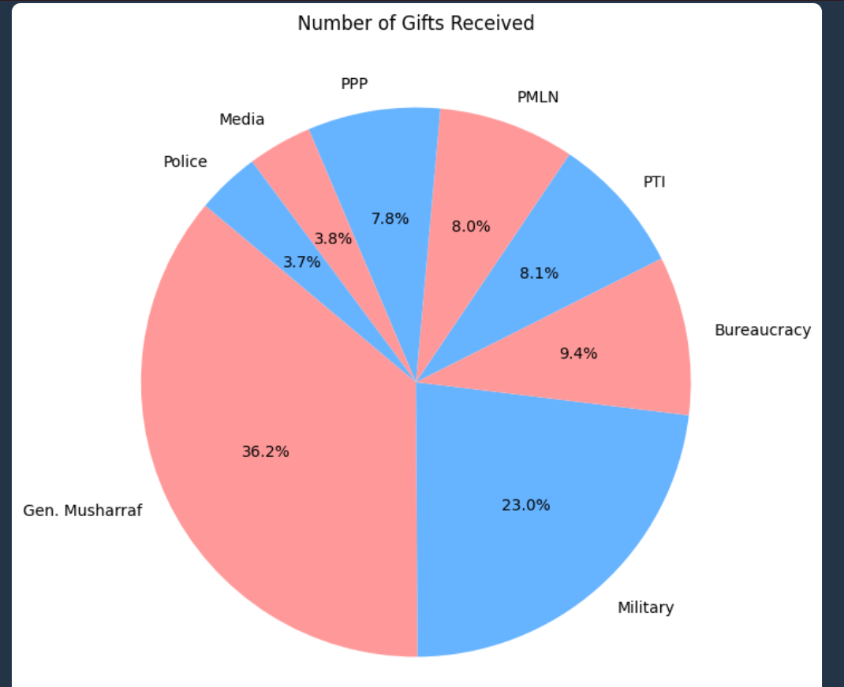

Description:
This pie chart shows the proportional share of Toshakhana gifts among the major affiliations: PTI, PMLN, PPP, Bureaucracy, Media, Police, Military, and Gen. Musharraf. It gives an at-a-glance view of which groups dominate the registry. The chart filters to only the most significant affiliations to avoid clutter from minor entries.

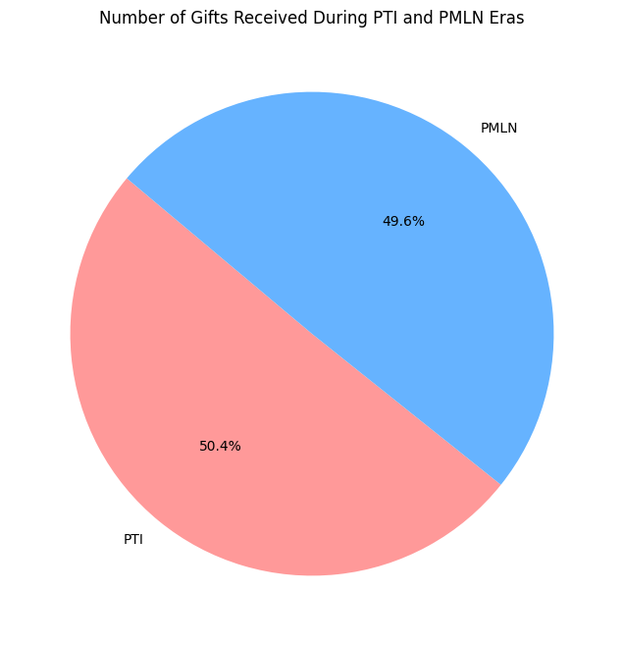

Description:
This focused pie chart isolates just PTI and PMLN affiliations to directly compare how many Toshakhana gifts were received during each party's tenure. It strips away all other affiliations to make the comparison as clear as possible. The result shows which party's era saw more gifts enter the registry — a politically significant finding given the public controversy around Toshakhana disclosures in Pakistan.

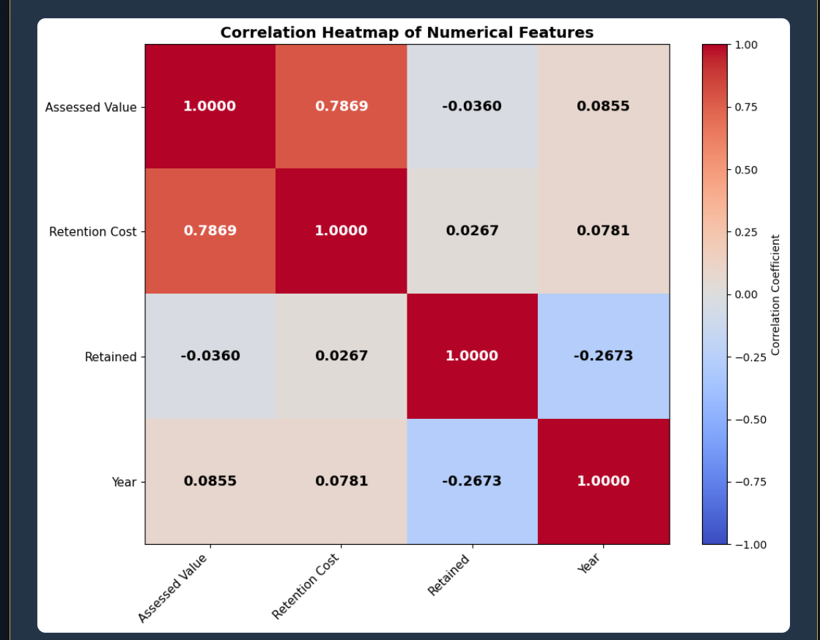

Description:
This heatmap visualises the Pearson correlation coefficients computed from 4,202 complete Toshakhana gift records spanning 2002 to 2022. Four numerical features are analysed: Assessed Value (the official valuation of each gift in PKR), Retention Cost (the fee paid to retain a gift), Retention Status (encoded as binary: 1 if the gift was retained, 0 if not — with an overall retention rate of approximately 88.5%), and Year (the year the gift was received). The strongest relationship in the dataset is between Assessed Value and Retention Cost (r = 0.7869), confirming that retention fees are largely proportional to gift value. Notably, the correlation between Year and Retention Status is −0.2673, suggesting that in more recent years, gifts are somewhat less likely to be retained than in earlier periods. Meanwhile, both Assessed Value and Retention Cost show only very weak positive correlations with Year (r ≈ 0.08), indicating that gift values have not significantly increased in real terms across the two decades covered by this dataset.

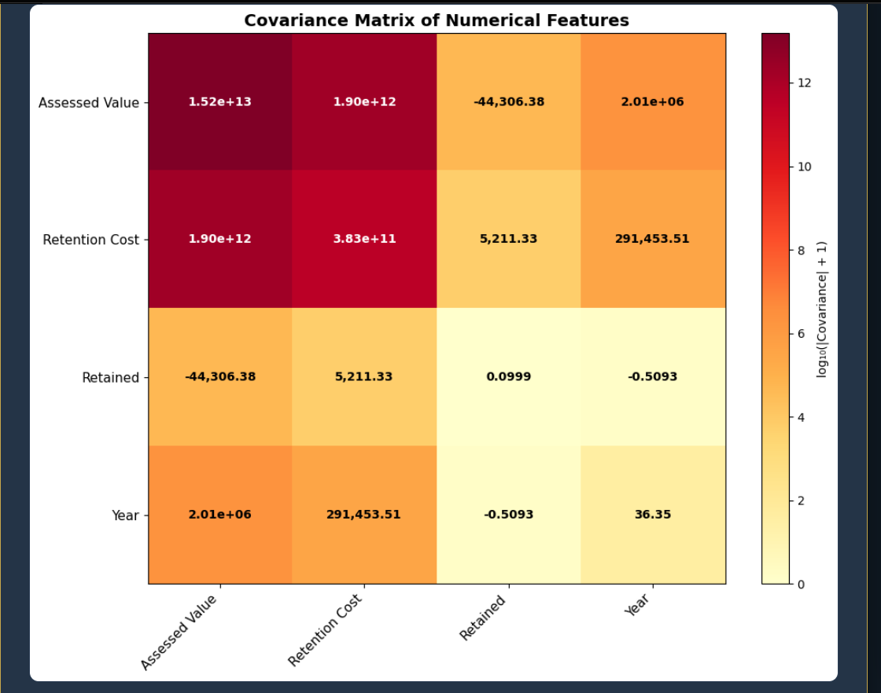

Description:
This heatmap displays the covariance matrix computed from the same 4,202 Toshakhana gift records used in the correlation analysis. Unlike correlation (which is normalised between −1 and +1), covariance preserves the original units and scales of the variables, making it useful for understanding the raw magnitude of how two features vary together. Because covariance values in this dataset span many orders of magnitude — from fractions like 0.0999 (Retained variance) to trillions like 1.52×10¹³ (Assessed Value variance) — the colour scale uses a logarithmic transformation (log₁₀ of absolute covariance) so that all cells remain visually distinguishable. The dominant cell is the Assessed Value × Retention Cost covariance at 1.90×10¹² PKR², reflecting the strong linear relationship between gift valuation and retention fees in the Toshakhana system.

Summary:
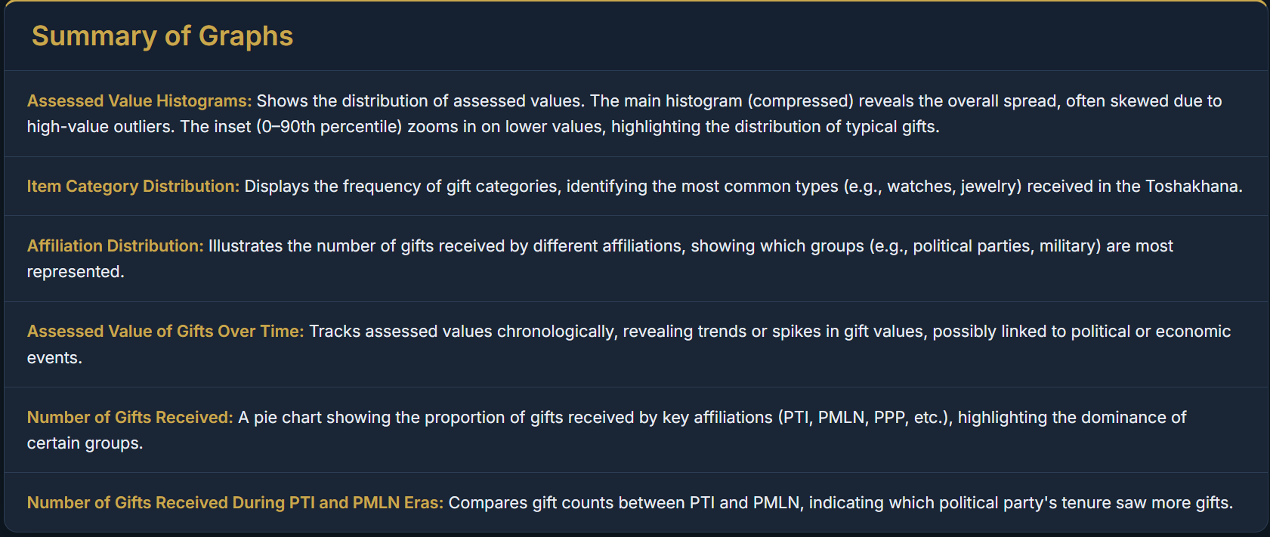

Probabilities containing conditional probabilities of affiliations and items category.

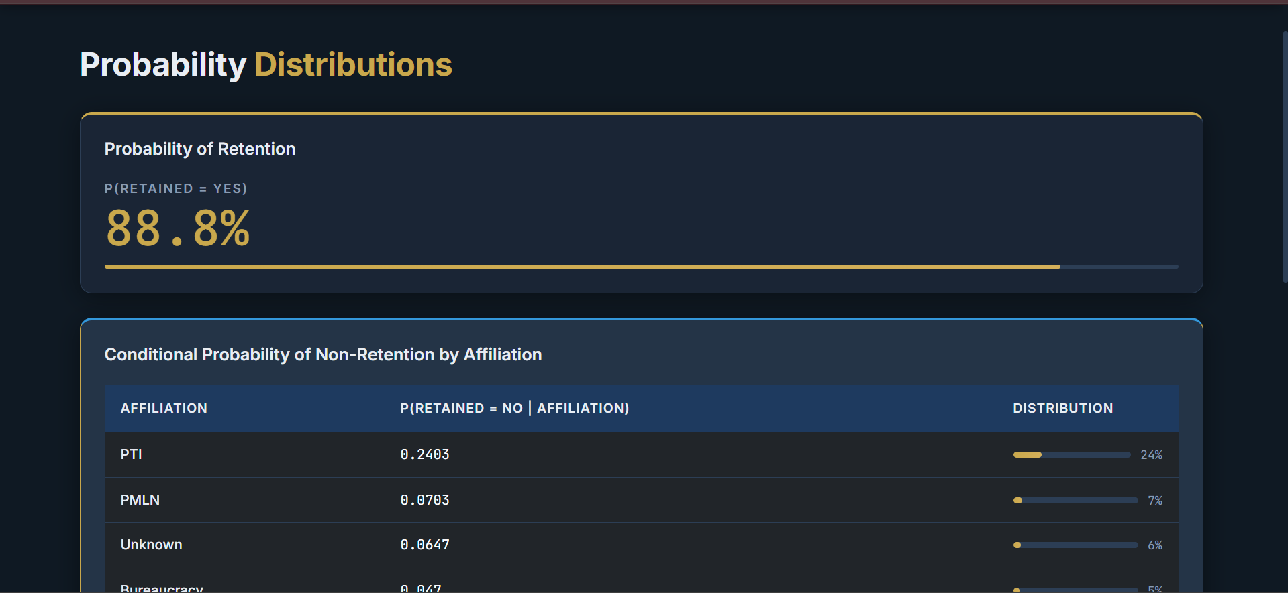
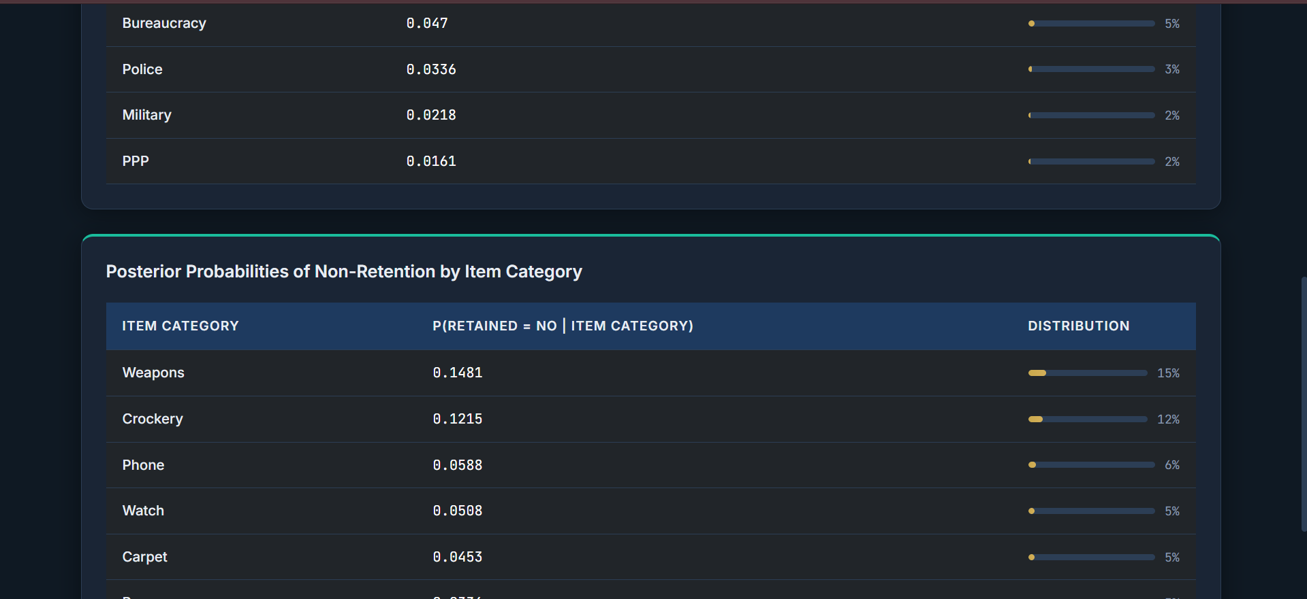
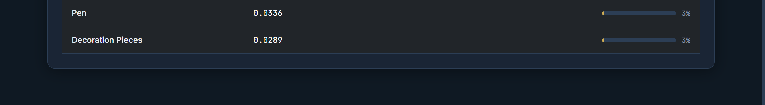

Regression Modelling contains a scatter plot of regression analysis as well as the contants defined.
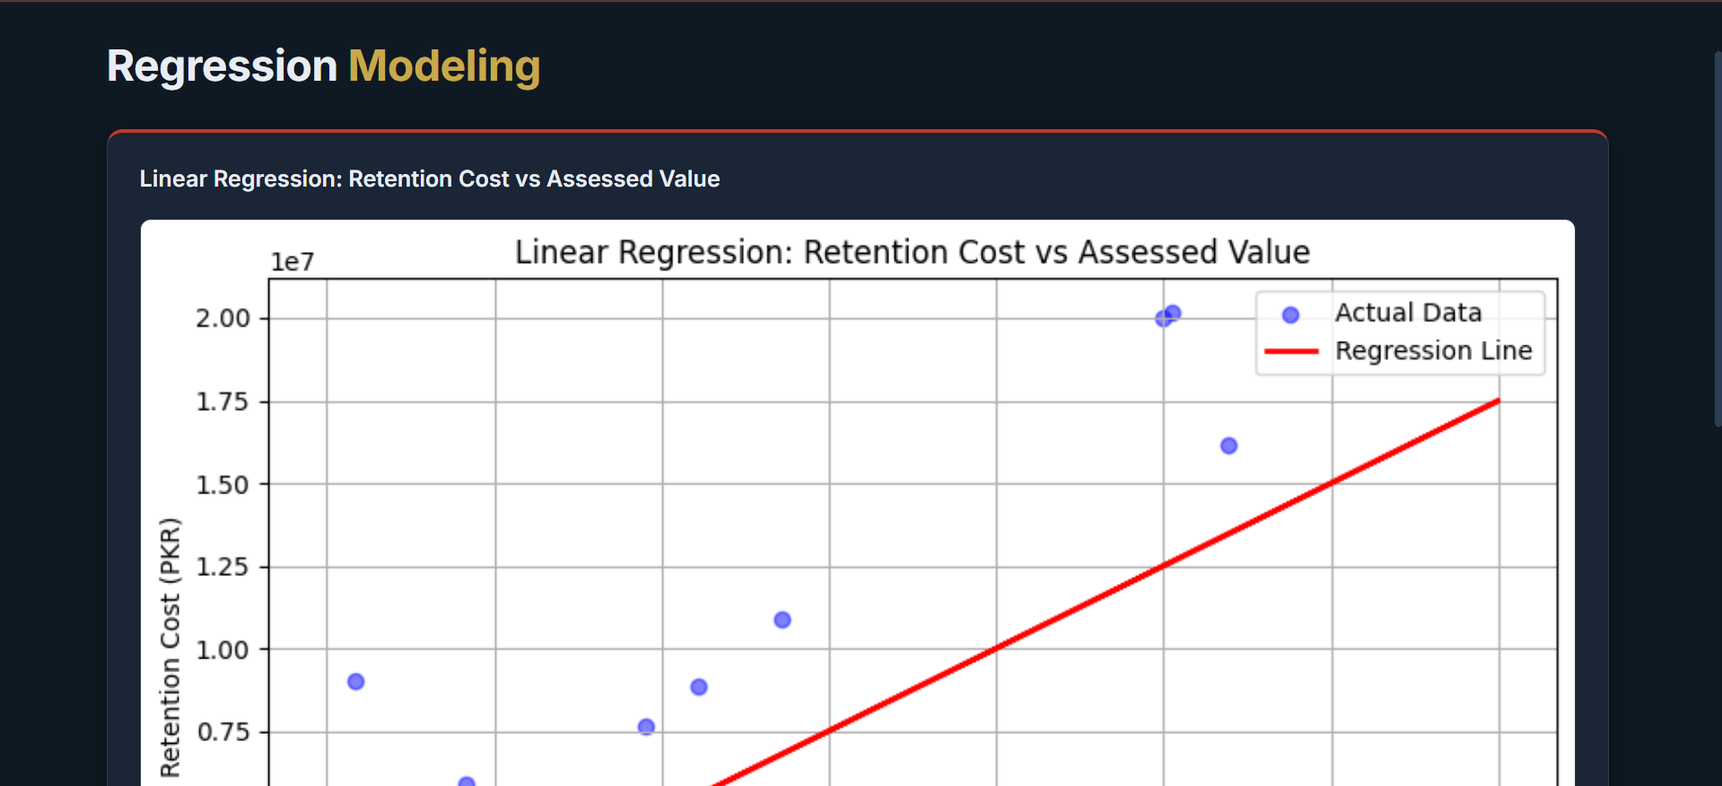
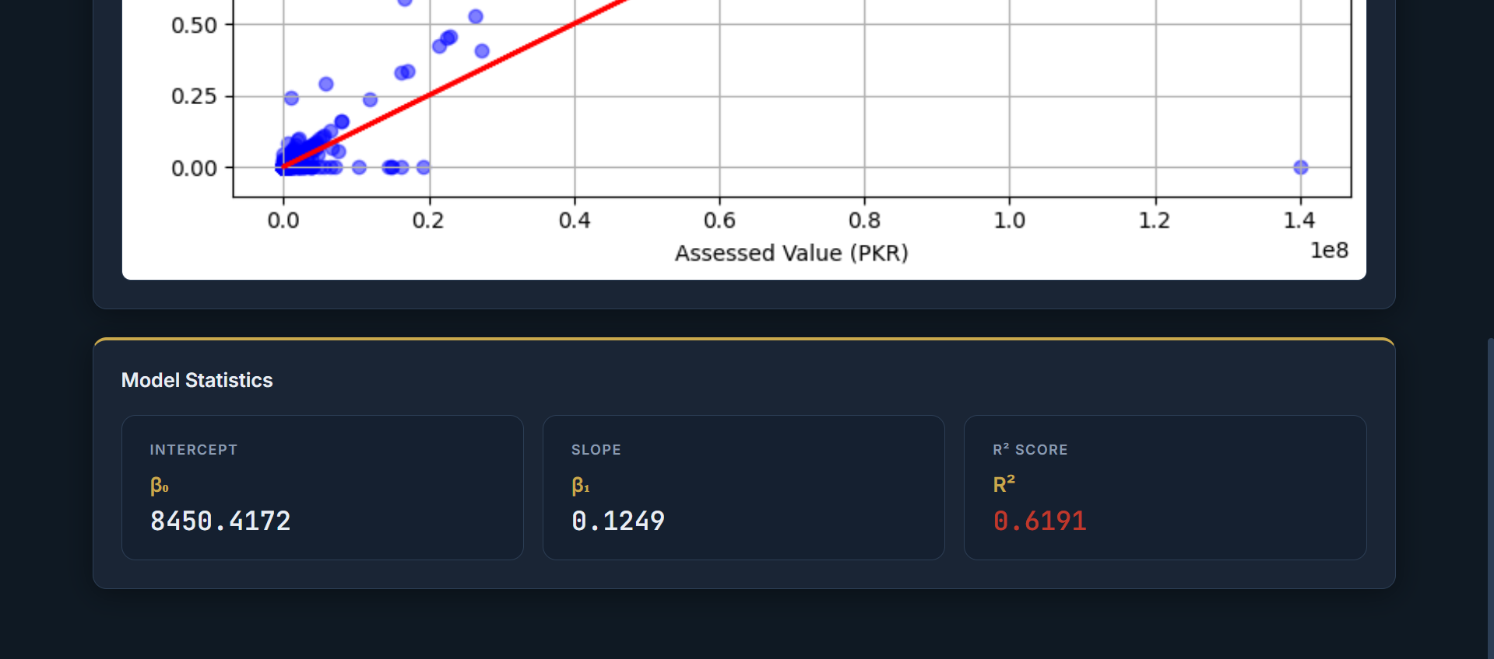

Code:

#fetching data and cleaning
import pandas as pd
df = pd.read_csv('Refined_TK_dataver2.csv') # adjust as needed
df['Affiliation'] = df['Affiliation'].fillna('Unknown')
#df = df.replace(to_replace='\n', value=" ", regex=True) #as we are replacing substring, so regex used
df['Affiliation'] = df['Affiliation'].replace({'Gen Mus':'Gen. Musharraf'}) #data munging in column 'Affiliation'
df['Affiliation'] = df['Affiliation'].replace({'Gen Mush':'Gen. Musharraf'})
df['Affiliation'] = df['Affiliation'].replace({'Gen. Musharrafarraf':'Gen. Musharraf'})
df['Detail of Gifts'] = df['Detail of Gifts'].replace({'One Carpet':'One carpet'})
df.sample(5)

#statistical tools
import matplotlib.pyplot as plt
pd.options.display.float_format = '{:,.0f}'.format
# Convert values to numeric and clean
df['Assessed Value'] = pd.to_numeric(df['Assessed Value'], errors='coerce')
df['Retention Cost'] = pd.to_numeric(df['Retention Cost'], errors='coerce')
# Drop rows where both are missing
df.dropna(subset=['Assessed Value', 'Retention Cost'], how='all', inplace=True)
# Summary stats
print(df[['Assessed Value', 'Retention Cost']].describe())

#histogram for assessed value
import matplotlib.pyplot as plt
from matplotlib import gridspec
# Set up main + inset axes
fig = plt.figure(figsize=(10, 6))
gs = gridspec.GridSpec(1, 2, width_ratios=[3, 1])
ax_main = plt.subplot(gs[0])
ax_inset = plt.subplot(gs[1])
# Main histogram (full data, compressed view)
ax_main.hist(df['Assessed Value'].dropna(), bins=100, color='skyblue', edgecolor='black')
ax_main.set_title("Full Distribution (Compressed)")
ax_main.set_xlabel("Assessed Value (PKR)")
ax_main.set_ylabel("Frequency")
# Inset histogram (only 0–99th percentile)
assessed_99 = df['Assessed Value'].quantile(0.90)
filtered = df[df['Assessed Value'] <= assessed_99]
ax_inset.hist(filtered['Assessed Value'], bins=50, color='orange', edgecolor='black')
ax_inset.set_title("Zoomed-in (0–90%)")
ax_inset.set_xlabel("Assessed Value")
plt.tight_layout()
plt.show()
#histogram for assessed value
import matplotlib.pyplot as plt
from matplotlib import gridspec
# Set up main + inset axes
fig = plt.figure(figsize=(10, 6))
gs = gridspec.GridSpec(1, 2, width_ratios=[3, 1])
ax_main = plt.subplot(gs[0])
ax_inset = plt.subplot(gs[1])
# Main histogram (full data, compressed view)
ax_main.hist(df['Assessed Value'].dropna(), bins=100, color='skyblue', edgecolor='black')
ax_main.set_title("Full Distribution (Compressed)")
ax_main.set_xlabel("Assessed Value (PKR)")
ax_main.set_ylabel("Frequency")
# Inset histogram (only 0–99th percentile)
assessed_99 = df['Assessed Value'].quantile(0.90)
filtered = df[df['Assessed Value'] <= assessed_99]
ax_inset.hist(filtered['Assessed Value'], bins=50, color='orange', edgecolor='black')
ax_inset.set_title("Zoomed-in (0–90%)")
ax_inset.set_xlabel("Assessed Value")
plt.tight_layout()
plt.show()

#Bar chart for item category
plt.figure(figsize=(10, 6))
df['Item Category'].value_counts().plot(kind='bar', color='lightgreen', edgecolor='black')
plt.title('Item Category Distribution')
plt.xlabel('Item Category')
plt.ylabel('Count')
plots.append({'title': 'Item Category Distribution', 'image': plot_to_base64()})

#Bar Chart for Affliation
# Graph 4: Affiliation Bar Plot
plt.figure(figsize=(10, 6))
df['Affiliation'].value_counts().plot(kind='bar', color='lightcoral', edgecolor='black')
plt.title('Affiliation Distribution')
plt.xlabel('Affiliation')
plt.ylabel('Count')
plots.append({'title': 'Affiliation Distribution', 'image': plot_to_base64()})

#Chart for assessed value over time
# 1. Convert to datetime (ignore bad formats)
df['Date'] = pd.to_datetime(df['Date'], errors='coerce')
# 2. Remove rows with invalid or missing dates or values
df = df.dropna(subset=['Date', 'Assessed Value'])
# 3. Sort by Date
df = df.sort_values('Date')
plt.figure(figsize=(10, 6))
plt.plot(df['Date'], df['Assessed Value'], marker='o', linestyle='-', color='b')
plt.ticklabel_format(style='plain' , axis = 'y')
plt.title('Assessed Value of Gifts Over Time')
plt.xlabel('Date')
plt.ylabel('Assessed Value')
plt.grid(True)
plt.show()

#Pie Chart for all affliation
filtered_df = df[df['Affiliation'].isin(['PTI', 'PMLN' ,'PPP' ,'Bureaucracy' , 'Media' ,'Police' ,'Military' ,'Gen. Musharraf'])]
# Count the number of gifts received by each affiliation
affiliation_counts = filtered_df['Affiliation'].value_counts()
# Plotting the pie chart
plt.figure(figsize=(8, 8))
plt.pie(affiliation_counts, labels=affiliation_counts.index, autopct='%1.1f%%', startangle=140, colors=['#ff9999','#66b3ff'])
plt.title('Number of Gifts Received ')
plt.show()

#PMLN vs PTI
filtered_df = df[df['Affiliation'].isin(['PTI', 'PMLN'])]
# Count the number of gifts received by each affiliation
affiliation_counts = filtered_df['Affiliation'].value_counts()
# Plotting the pie chart
plt.figure(figsize=(8, 8))
plt.pie(affiliation_counts, labels=affiliation_counts.index, autopct='%1.1f%%', startangle=140, colors=['#ff9999','#66b3ff'])
plt.title('Number of Gifts Received During PTI and PMLN Eras')
plt.show()

#Probabilities
retained_prob = df['Retained'].value_counts(normalize=True).get('Yes', 0)
print(f"Probability of a gift being retained: {retained_prob:.2f}")
pd.set_option('display.float_format', '{:.4f}'.format) # show 4 decimal places
affiliation_group = df.groupby('Affiliation')['Retained'].value_counts(normalize=True).unstack()
print("Conditional Probability of Not Retention by Affiliation:")
print(affiliation_group['No'].dropna().sort_values(ascending=False))
category_group = df.groupby('Item Category')['Retained'].value_counts(normalize=True).unstack()
posterior = category_group['No'].dropna()
print("Posterior probabilities (P(Retained=Not | Item Category)):")
print(posterior.sort_values(ascending=False))

Correlation HeatMap
df_corr = df.copy()
df_corr['Retained_Binary'] = df_corr['Retained'].apply(
lambda x: 1 if str(x).strip().lower() in ('yes', 'retained') else 0
)
df_corr['Date_Parsed'] = pd.to_datetime(df_corr['Date'], errors='coerce')
df_corr['Year'] = df_corr['Date_Parsed'].dt.year

numeric_cols = ['Assessed Value', 'Retention Cost', 'Retained_Binary', 'Year']
display_labels = ['Assessed Value', 'Retention Cost', 'Retained', 'Year']
corr_data = df_corr[numeric_cols].dropna()
corr_matrix = corr_data.corr()

fig, ax = plt.subplots(figsize=(10, 8))
im = ax.imshow(corr_matrix.values, cmap='coolwarm', aspect='auto', vmin=-1, vmax=1)

ax.set_xticks(range(len(numeric_cols)))
ax.set_yticks(range(len(numeric_cols)))
ax.set_xticklabels(display_labels, rotation=45, ha='right', fontsize=11)
ax.set_yticklabels(display_labels, fontsize=11)

for i in range(len(corr_matrix)):
for j in range(len(corr_matrix)):
val = corr_matrix.iloc[i, j]
color = 'white' if abs(val) > 0.5 else 'black'
ax.text(j, i, f'{val:.4f}',
ha='center', va='center', color=color, fontsize=13, fontweight='bold')

plt.colorbar(im, label='Correlation Coefficient')
plt.title('Correlation Heatmap of Numerical Features', fontsize=14, fontweight='bold')
plt.tight_layout()
plots.append({'title': 'Correlation Heatmap', 'image': plot_to_base64()})

plot_cache[cache_key] = plots
return plots
except Exception as e:
return [{'title': 'Error', 'image': None, 'error': f"Error generating graphs: {str(e)}"}]

CoVariance HeatMap
# Graph 9: Covariance Heatmap
df_cov = df.copy()
df_cov['Retained_Binary'] = df_cov['Retained'].apply(
lambda x: 1 if str(x).strip().lower() in ('yes', 'retained') else 0
)
df_cov['Date_Parsed'] = pd.to_datetime(df_cov['Date'], errors='coerce')
df_cov['Year'] = df_cov['Date_Parsed'].dt.year

cov_cols = ['Assessed Value', 'Retention Cost', 'Retained_Binary', 'Year']
cov_labels = ['Assessed Value', 'Retention Cost', 'Retained', 'Year']
cov_data = df_cov[cov_cols].dropna()
cov_matrix = cov_data.cov()

fig, ax = plt.subplots(figsize=(10, 8))
log_abs = np.log10(np.abs(cov_matrix.values) + 1)
max_val = log_abs.max()
im = ax.imshow(log_abs, cmap='YlOrRd', aspect='auto', vmin=0, vmax=max_val)

ax.set_xticks(range(len(cov_cols)))
ax.set_yticks(range(len(cov_cols)))
ax.set_xticklabels(cov_labels, rotation=45, ha='right', fontsize=11)
ax.set_yticklabels(cov_labels, fontsize=11)

for i in range(len(cov_matrix)):
for j in range(len(cov_matrix)):
val = cov_matrix.iloc[i, j]
if abs(val) >= 1e6:
txt = f'{val:.2e}'
elif abs(val) >= 1:
txt = f'{val:,.2f}'
else:
txt = f'{val:.4f}'
brightness = log_abs[i, j] / max_val if max_val > 0 else 0
color = 'white' if brightness > 0.6 else 'black'
ax.text(j, i, txt,
ha='center', va='center', color=color, fontsize=10, fontweight='bold')

plt.colorbar(im, label='log\u2081\u2080(|Covariance| + 1)')
plt.title('Covariance Matrix of Numerical Features', fontsize=14, fontweight='bold')
plt.tight_layout()
plots.append({'title': 'Covariance Matrix', 'image': plot_to_base64()})

#linear Regression
from sklearn.linear_model import LinearRegression
from sklearn.metrics import r2_score
# Drop rows with missing values in relevant columns
df = df.dropna(subset=['Assessed Value', 'Retention Cost'])
# Reshape data for sklearn
X = df[['Assessed Value']] # 2D array
y = df['Retention Cost'] # 1D array
# Fit Linear Regression Model
model = LinearRegression()
model.fit(X, y)
# Predict values
y_pred = model.predict(X)
# Plot actual vs predicted
plt.figure(figsize=(8, 5))
plt.scatter(X, y, color='blue', alpha=0.5, label='Actual Data')
plt.plot(X, y_pred, color='red', linewidth=2, label='Regression Line')
plt.title("Linear Regression: Retention Cost vs Assessed Value")
plt.xlabel("Assessed Value (PKR)")
plt.ylabel("Retention Cost (PKR)")
plt.legend()
plt.grid(True)
plt.tight_layout()
plt.show()
# Print model stats
print("Intercept (β₀):", model.intercept_)
print("Slope (β₁):", model.coef_[0])
print("R² Score:", r2_score(y, y_pred))

Conclusion:
Based on the analysis of the Toshakhana dataset, it can be observed that Pervez Musharraf received the highest number of gifts among all recorded officials, indicating a significantly higher frequency of gift exchanges during his tenure compared to others.
Furthermore, the item-level analysis reveals that watches constitute the most frequently gifted category, suggesting a strong preference for luxury timepieces in diplomatic gift exchanges. This trend may reflect both the symbolic and material value associated with such items in international relations.
In terms of political affiliation, Pakistan Tehreek-e-Insaf (PTI) has received a greater number of gifts overall compared to Pakistan Muslim League (N) (PML-N). This indicates a comparatively higher volume of recorded gift transactions associated with PTI-linked office holders within the dataset.
However, when examining retention behavior, it is notable that approximately 24% of the gifts received by PTI-affiliated individuals were not retained, implying either their return to the Toshakhana repository or non-acquisition by the recipients. This highlights a measurable variation in retention patterns, which may reflect differences in policy adherence, valuation considerations, or administrative decisions.
Overall, these findings provide insight into distribution patterns, item preferences, and retention dynamics within the Toshakhana system, forming a basis for further statistical and comparative analysis.

